|  |
| --- |
| **TEST CODE : TCS17-05T**  Total number of question : 10  Test duration (min) : 20 min  Correct attempt (mark) : 1  Wrong attempt (mark) : Nil |



**TECHNICAL**

*Certain questions are self-explanatory. Thus detailed solutions are provided only wherever required.*

**1**. What the below statement will print if a=5? printf("%d %d",a, !a++);

a. 5 0 b. 6 0 c. 5 1 d. 6 1

**Answer:** B

**Explanation**:

Values in the function get passed from right to left. First !a++ get processed which pass zero as argument and make a equal to 6

**2**. What is the output?

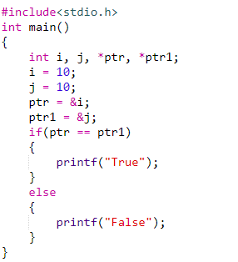

a. 1 b. False c. Compiler Error d. No output

**Answer:** B

**Explanation:**

In this program we are comparing the addresses contained by ptr & ptr1 not the value at those addresses and pointers ptr and ptr1 have the addresses of different variables so above condition is false

**3**. How many times main() will get called?

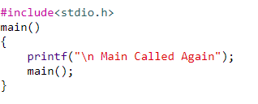

a. Error b. Infinite times

c. No output d. None of these

**Answer:** B

**Explanation:**

There is no condition in the main() to stop the recursive calling of the main() hence it will be called infinite no of times.

**4**. Comment on the following?

const int *ptr;

a. You cannot change the value pointed by ptr

b. You can change the value of the pointer

c. None of these

d. You can change the pointer as well as the value pointed by it

**Answer:** A

**Explanation:**

Value of the pointer cannot be changed when const keyword is used

**5**. What is the output of the following program?

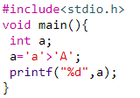

a. NULL b. Error c. 0 d. 1

**Answer:** D

**Explanation:**

ASCII codes are compared. ’A’ is 65 while ’a’ is 97

**6**. What is the output of the following program?

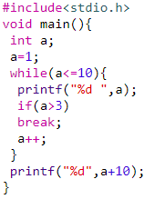

a. 1 2 3 4 10 b. 1 2 3 4 14

c. 1 2 3 13 d. 1 2 3 14

**Answer:** B

**Explanation:**

1,2,3,4 are printed. When a value is greater than 4, if condition becomes true and break is executed. (4+10)14 is printed

**7**. Which of the following does not initialize ptr to null (assuming variable declaration of a as int a=0)?

a.int *ptr = &a; b. int *ptr = &a - &a;

c.int *ptr = a -a; d. None of these

**Answer:** A

**Explanation:**

In *ptr = &a, the address of a is stored in pointer. In other cases, it is 0

**8**. What is the output of the following program?

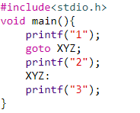

a. 3 b.13 c. 123 d. 12

**Answer:** B

**Explanation:**

go to statement jumps program execution to the label XYZ and skips 2.

**9**. The statement that transfers control to the beginning of the loop is called _______.

a. Break statement b. Exit statement

c. Goto statement d. continue statement

**Answer:** D

**Explanation:**

Continue statement continues with the next iteration of the loop

**10**. What is the output of following program?

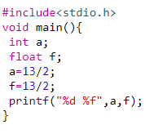

a. 6 6.500000 b. 6 6.5

c. 6 6.000000 d. None of these

**Answer:** C

**Explanation:**

Solution of 13/2 is obtained as an integer and decimal values are dropped before assigning to f